Property Rights for Business Owners in Colorado
Colorado business owners have inalienable property rights, protected by the Colorado Constitution. The word “inalienable” means that those rights cannot be taken away from you unless you voluntarily give them up. These rights are natural to all and as the Declaration of Independence reminds us, they were endowed to us by “The Creator.” Our rights were not issued to us by the U.S. Constitution, or any governing body.

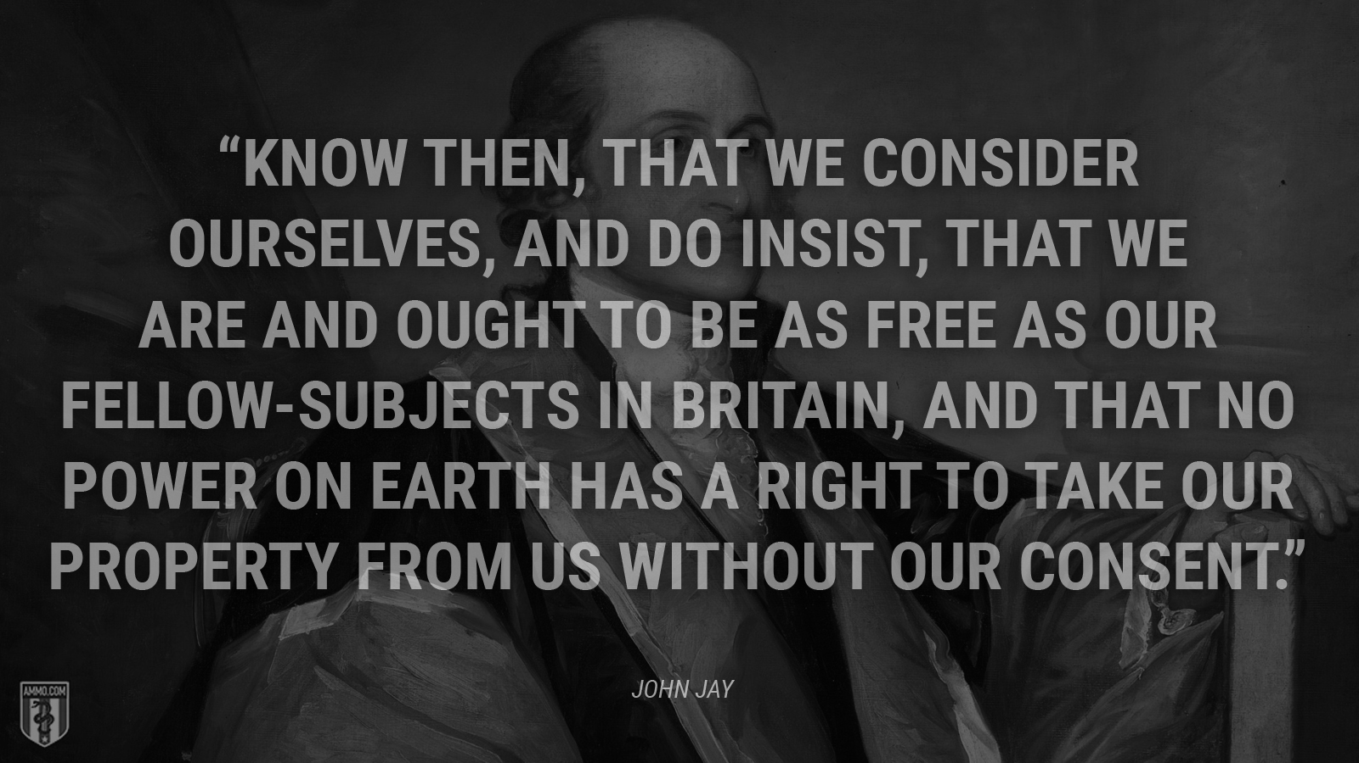

It is vital for all business owners to understand their rights especially during these times when unelected boards like the health agencies are using bully-tactic “advisories” to dictate what a business can do with facial mask wearing, etc.

For your protection, you should post these sections of the Colorado Constitution on your door and train your employees to understand them. Always be respectful to law enforcement but if they pressure you to close down or to obey these “advisories” then do your DUTY of educating them on the Supreme Law of our state.

“Advisory” statements from an unelected board are not regulatory. They are not laws. If you receive complaints or citations, refuse to comply because you are the one in control of your business.
SUPREME Law of Colorado

The Colorado Constitution was written to protect the citizens first and then the government was created afterwards. Article 2 Bill of Rights, Section 3 states: “All persons have certain natural, essential and inalienable rights, among which may be reckoned the right of enjoying and defending their lives and liberties; of acquiring, possessing and protecting property; and of seeking and obtaining their safety and happiness.”
Article 2, sections 1, 3, 14 & 15 explain how ALL political power is vested in the people and that the governments only have their authority from the consent of the governed and that those rights include protecting property rights and no governing body can infringe on this right without just compensation for it.

Section 1, reads as follows: “All political power is vested in and derived from the people; all government, of right, originates from the people, is founded upon their will only, and is instituted solely for the good of the whole.”

Section 3, states: “All persons have certain natural, essential and inalienable rights, among which may be reckoned the right of enjoying and defending their lives and liberties; of acquiring, possessing and protecting property; and of seeking and obtaining their safety and happiness.

Section 14 says “Taking private property for private use. Private property shall not be taken for private use unless by consent of the owner, except for private ways of necessity, and except for reservoirs, drains, flumes or ditches on or across the lands of others, for agricultural, mining, milling, domestic or sanitary purposes”

Section 15 states: “whenever an attempt is made to take private property for a use alleged to be public, the question whether the contemplated use be really public shall be a judicial question, and determined as such without regard to any legislative assertion that the use is public.”
Mybizmyrights.com – *Website under construction but will be up soon.

